**what is the benefit of using master-slave architecture rather than building on master only ?**

* Scalability: Distributes the workload across multiple slave nodes, enabling a higher number of concurrent builds and reducing build queue times.
* Performance and Efficiency: Prevents resource contention on the master node, allowing it to focus on managing job configurations and monitoring the system.
* Resource Utilization: Optimizes resource usage by leveraging idle or underutilized resources on different slave nodes.
* Platform Compatibility: Enables building and testing on multiple operating systems and environments.
* Fault Tolerance and High Availability: Increases system resilience by redistributing workload if a slave node fails.
* Security: Restricts direct access to the master node, reducing potential vulnerabilities.
* Flexibility and Customization: Tailors slave nodes to specific project requirements, such as software, libraries, or hardware configurations.

**what is different between authorization and authentication ?**

authentication verifies the identity of a user or entity, while authorization determines what actions or operations that authenticated user or entity is allowed to perform. Authentication establishes trust, while authorization defines permissions and access rights. Both authentication and authorization are essential components of a secure system, working together to control access and protect resources.

**make jenkins-shared-library and make your jenkinsfile which you used in lab2 to point to this library**

https://github.com/Ali-ELHaggar/JenkinsLab02

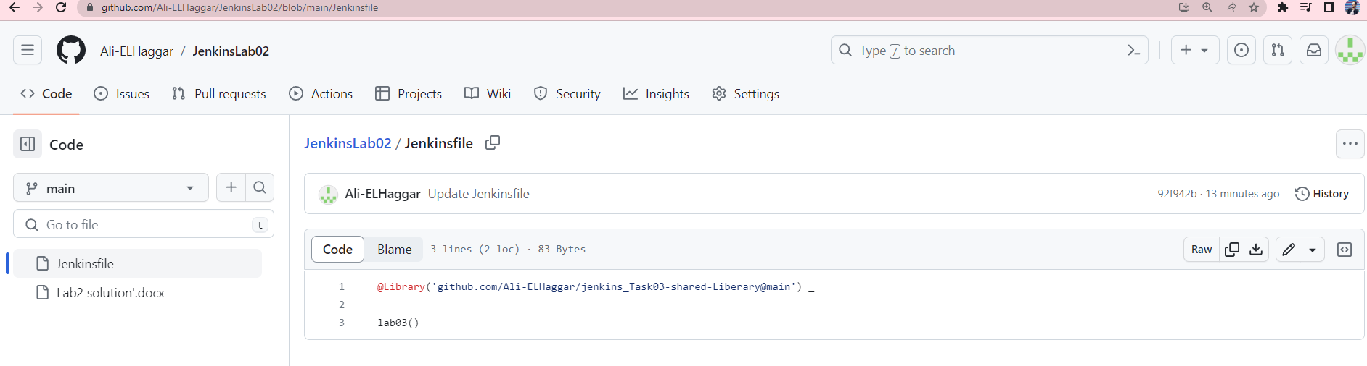 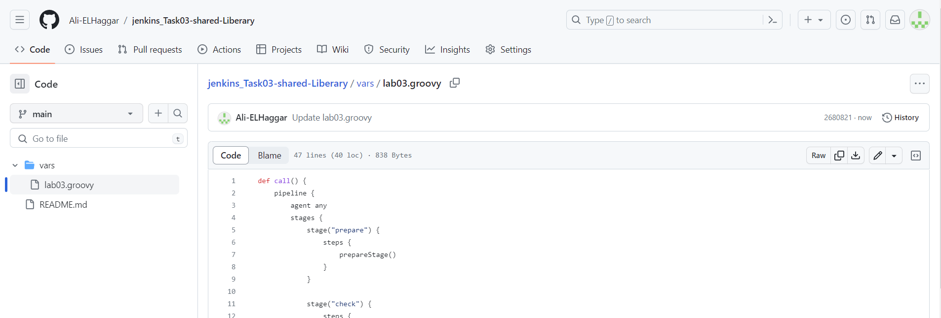

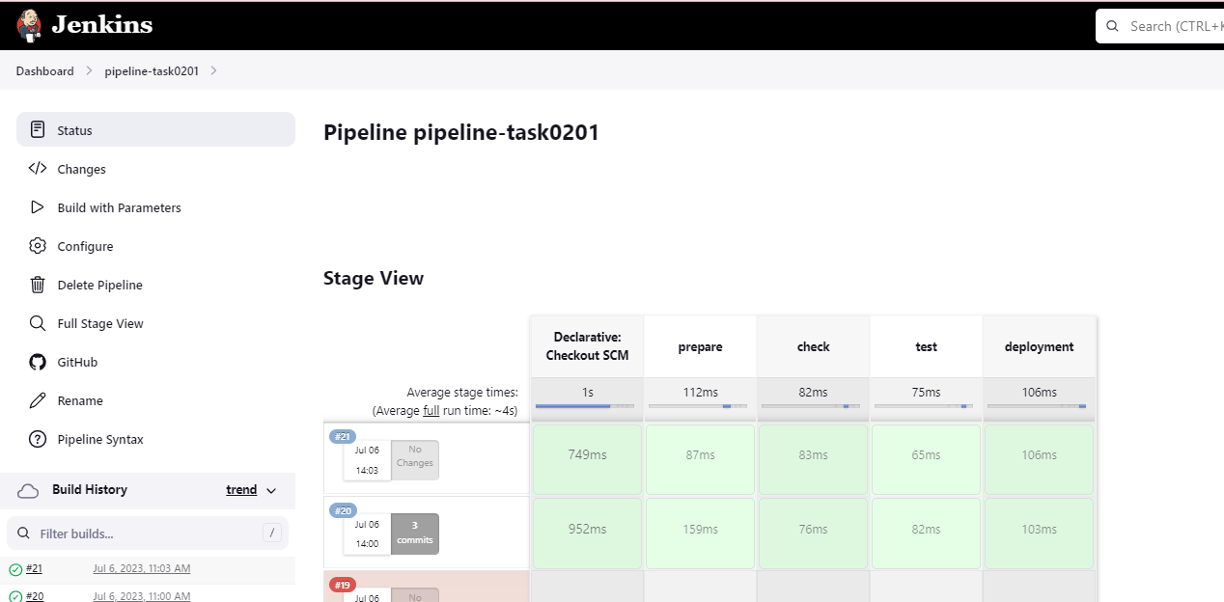

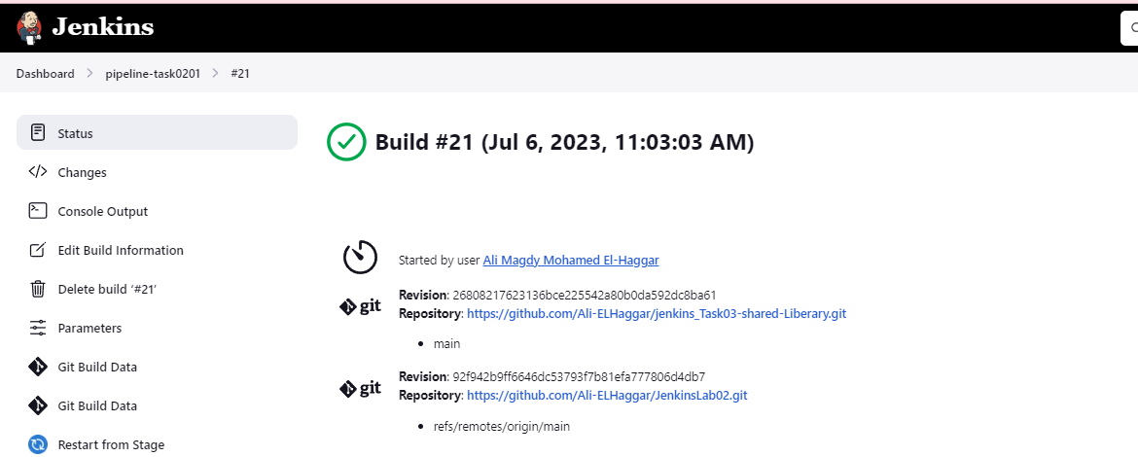

try to make new slave as container or ec2 server and configure master to use it

